IOT(INTERNET METHODIST COLLEGE OF ENGINEERING&TECNOLOGYOF THINGS) 

DONE BY

:-SRIHITHA(7051)

:-SNEHA(7065)

Contactless door bell using arduino

.introduction

• **A contactless doorbell is an innovative device designed to minimize physical contact and enhance convenience. It typically uses technology such as motion sensors, infrared sensors, or smartphone apps to detect a**

**person's presence and trigger a notification or chime. This helps reduce the spread of germs, making it**

**especially relevant in times of increased hygiene**

**awareness. Some models also incorporate video features for added security.**

Components:

•

**Creating a contactless doorbell using Arduino can be a fun and practical project. Here's a simple list of components you might need for a basic setup:**

• **Arduino Board:**

• **Any Arduino board (e.g., Arduino Uno, Arduino Nano).**

• **Buzzer or Speaker:**

• **To generate the doorbell sound.**

• **LEDs (Optional):**

• **LEDs for visual indication (e.g., to show that the doorbell has been pressed).**

•Jumper Wires:

•To connect the components on the breadboard.

•Breadboard:

•For prototyping and connecting the components. • **Ultrasonic Sensor:**

• **HC-SR04 is a commonly used ultrasonic sensor for measuring distance.**

• **Resistors:**

• **A few resistors for protecting the LEDs and the ultrasonic sensor.**

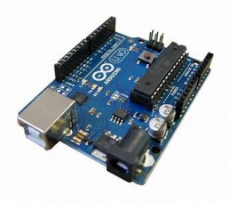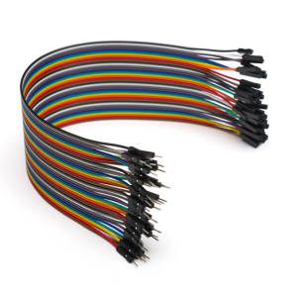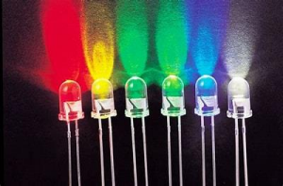

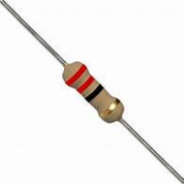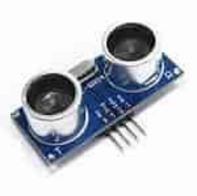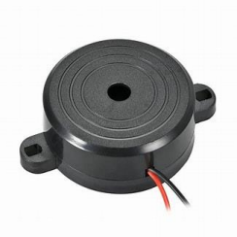

Circuit diagram:

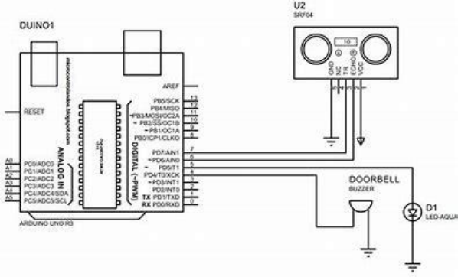

CODE:

• **//Tech Trends Shameer**

• **//Contactless Doorbell**

• **// Define pins numbers**

• **const int trigPin = 13; //Connect Trig pin in Ultrasonic Sensor to Arduino Pin 13** • **const int echoPin = 12; //Connect Echo pin in Ultrasonic Sensor to Arduino Pin 13** • **const int relay= 10; //Connect Positive pin of LED to Arduino Pin 10** • **// Define variables**

• **long duration;**

• **int distance;**

• **int safetyDistance;**

• **void setup() {**

• **pinMode(trigPin, OUTPUT); // Sets the trigPin as an Output**

• **pinMode(echoPin, INPUT); // Sets the echoPin as an Input**

• **void loop() {**

• **// Clears the trigPin**

• **digitalWrite(trigPin, LOW);**

• **delayMicroseconds(2);**

• **// Sets the trigPin on HIGH state for 15 micro seconds** • **digitalWrite(trigPin, HIGH);**

• **delayMicroseconds(15);**

• **digitalWrite(trigPin, LOW);**

• **// Reads the echoPin, returns the sound wave travel time in microseconds** • **duration = pulseIn(echoPin, HIGH);**

•

• **// Calculate the distance**

• **distance= duration*0.034/2;**

• **safetyDistance = distance;**

• **if (safetyDistance <= 10){**

• **digitalWrite(relay, HIGH);**

• **}**

• **else{**

• **digitalWrite(relay, LOW);**

• **}**

• **// Print the distance on the Serial Monitor** • **Serial.print("Distance: ");**

• **Serial.println(distance);**

• **}**

USES:

• The contactless doorbell project offers several practical uses:

• Hygiene and Safety:

• Minimizes physical contact, promoting hygiene and reducing the risk of germ transmission. • Convenience:

• Provides a hassle-free way for visitors to announce their presence without physically pressing a button. • Accessibility:

• Benefits individuals with mobility issues who may find it challenging to reach and press a traditional doorbell.

• Security:

•ADVANTAGES:

• Integrated cameras allow homeowners to visually verify visitors before opening the door, enhancing security.

• Smart Home Integration:

• Connects with smart home systems, enabling automation and integration with other devices like lights or surveillance systems.

• Notification Alerts:

• Sends alerts to smartphones or other devices when someone is at the door, even when occupants are away from home.

Conclusion:

• As technology continues to advance, projects like the contactless doorbell showcase how innovation can address practical concerns, making everyday interactions safer, more accessible, and in tune with the demands of modern living. Whether implemented as a standalone DIY project or integrated into existing smart home ecosystems, the contactless doorbell stands as a testament to the possibilities that arise when technology meets everyday convenience.

THANK YOU.....